Themes

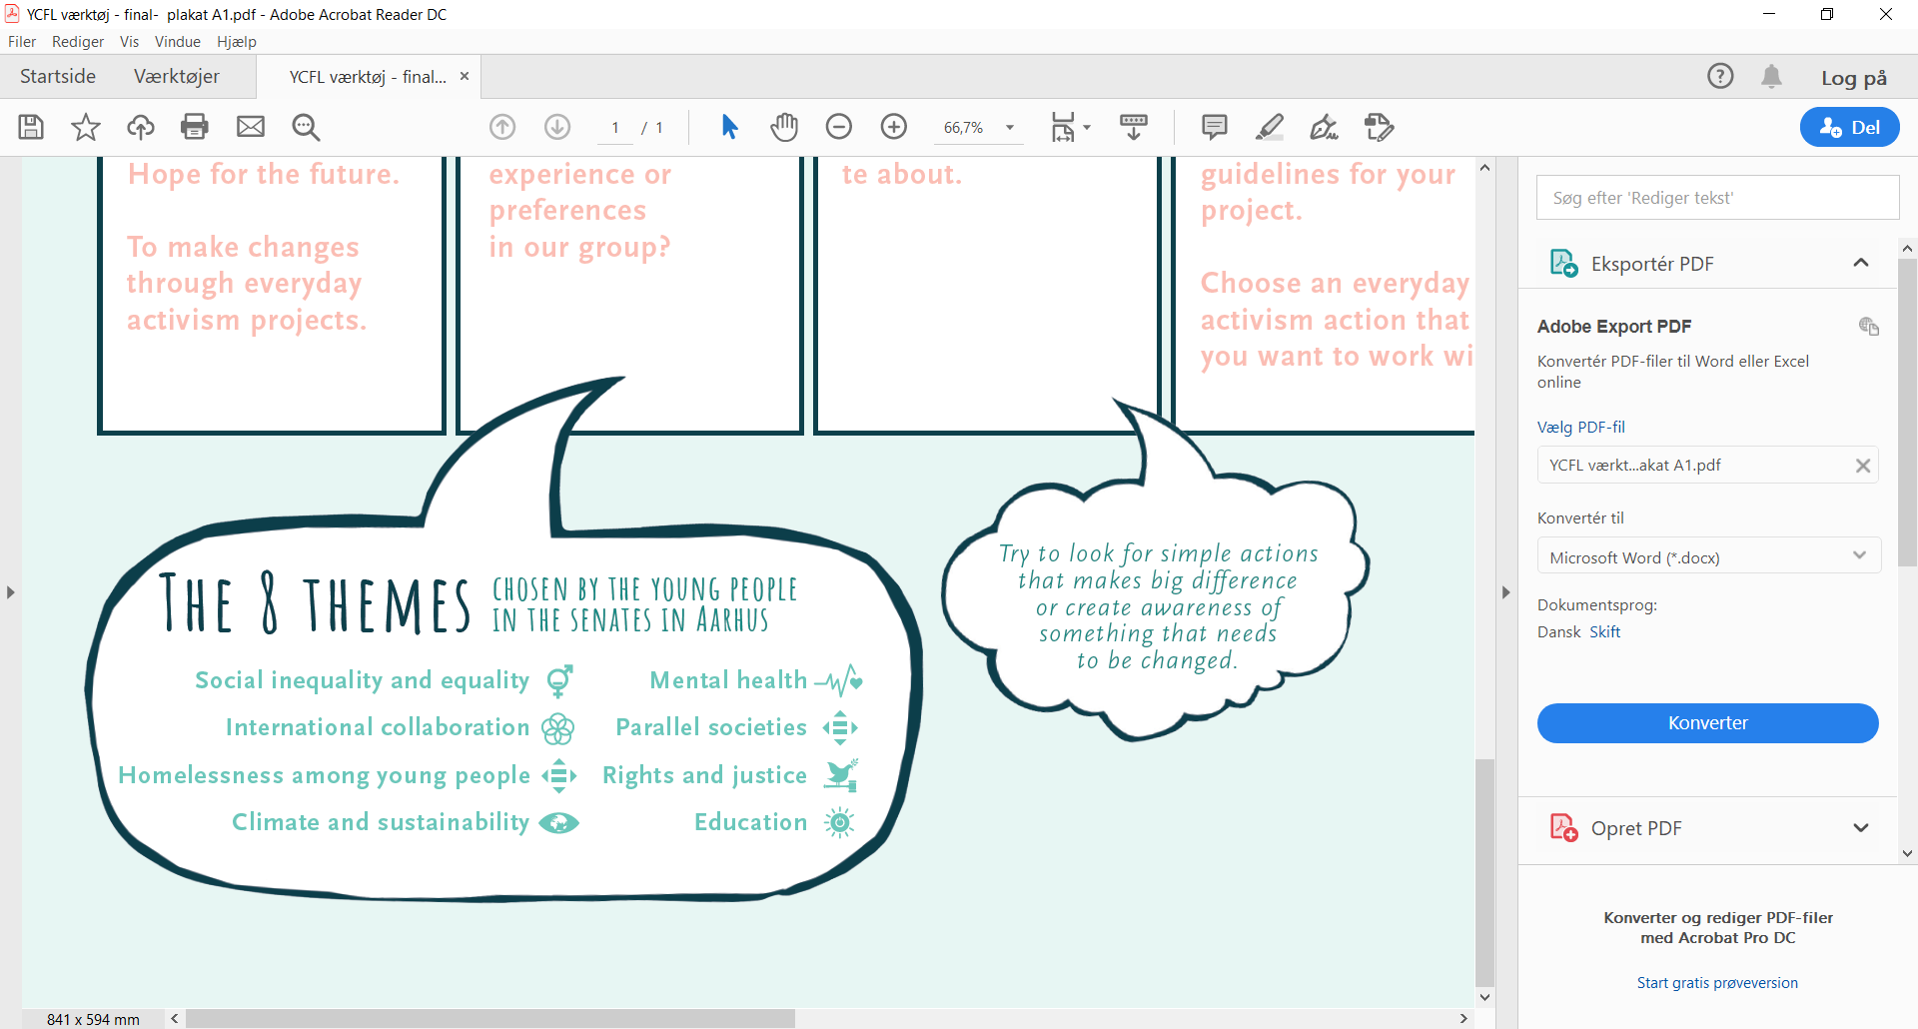  The theme is based on Sustainable development goal no.17:  Partnerships for the goals. | The theme is based on Sustainable development goal no. 5:  Gender equality and no. 10:  Reduced inequalities | The theme is based on Sustainable development goal no.10:  Reduced inequalities | The theme is based on Sustainable development goal no. 13:  Climate action
The theme is based on Sustainable development goal no.3:  Good health and well-being | The theme is based on Sustainable development goal no. 10:  Reduced inequalities | The theme is based on Sustainable development goal no. 16:  Peace, justice and strong institutions | The theme is based on Sustainable development goal no. 4:  Quality education

