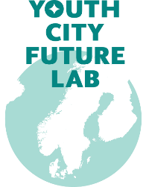

SCRIPT
Fill out the form to prepare your everyday activism action
TITLE OF PROJECT

THEME

DESCRIPTION OF PROJECT – PURPOSE, GOALS AND DREAMS
Describe in a few words the purpose of your activism project
How will our action make a change or a better world - and for whom?

Goals and guidelines/ success criteria:
When will we know we succeeded?

RESSOURCER
What does it require of materials, time, people, and finances?
Do we need help from someone - permits?

GAMEPLAN
Who´s doing what - when?

Step 1, 2, 3…

What to do | When to do | Who and how

COMMUNICATIONS STRATEGY
Your need to tell your story. Plan what to communicate. Formulate the 3 most important messages:

- ______________________________________________________________________

- ______________________________________________________________________

- ______________________________________________________________________

How do you communicate: SoMe, blogs, flyers, posters, local newspaper, text message, happening etc.
When and to whom: your local community, organizations, the YCFL community, friends, and family etc.
.

MAKE DOCUMENTARY
How and when will we document our actions? (photo, video …)
Who is the target audience?

TIMELINE

Start date



WHATS THE BEST ABOUT PARTICIPATING IN THIS PROJECT?
Free interpretation

Contactinformation:
Email, phone, SoMe

Projectmanager:

Team-members:

